Niladri Bhandari

Virtusa

Smart Asset Finance MVP

Table of Contents

1. Environment Setup details 3

2. Screen Flow 5

# 

# Environment Setup details

1. Hardware Requirement

OS: Ubuntu t2.xlarge is recommended and 100 GB disk space

1. Create instance from the AMI – virtusa-ethereum-assetfinance ( 898980891534/virtusa-ethereum-assetfinance)

Please wait till initialisation complete.

1. Following ports should be open

8080: Smart Asset finance application

8101: Block chain RPC port (Opening port is Optional)

3306: MySql Server Port (Opening port is Optional)

1. Start the application by running startAll.sh in /home/Ubuntu. It will start

* AssetFinance application
* MySql server
* Ethereum blockchain
* Expected Log:

**ubuntu@ip-172XXXXX**:**~**$ ls

**AssetFinance**  **ethereumchain**  nohup.out  reademe  **startAll.sh**

**ubuntu@ip-172-XXXX**:**~**$ ./startAll.sh

Starting MySql.....

Starting Assetfinance Application

[PM2] Applying action restartProcessId on app [index](ids: 0)

[PM2] [index](0) ✓

[PM2] Process successfully started

┌──────────┬────┬──────┬──────┬────────┬─────────┬────────┬─────┬───────────┬────────┬──────────┐

│ **App name** │ **id** │ **mode** │ **pid** │ **status** │ **restart** │ **uptime** │ **cpu** │ **mem** │ **user** │ **watching** │

├──────────┼────┼──────┼──────┼────────┼─────────┼────────┼─────┼───────────┼────────┼──────────┤

│ **index** │ 0  │ **fork** │ 5527 │ **online** │ 0       │ 0s     │ 0%  │ 13.0 MB   │ **ubuntu** │ disabled │

└──────────┴────┴──────┴──────┴────────┴─────────┴────────┴─────┴───────────┴────────┴──────────┘

*Use `pm2 show <id|name>` to get more details about an app*

Starting blockchain

nohup: appending output to 'nohup.out'

**ubuntu@ip-172-XXXXX**:**~**$ tail nohup.out

INFO [11-23|18:47:22] Loaded local transaction journal         transactions=0 dropped=0

INFO [11-23|18:47:22] Regenerated local transaction journal    transactions=0 accounts=0

INFO [11-23|18:47:22] Starting P2P networking

INFO [11-23|18:47:22] RLPx listener up                         self="enode://2e39864a71d2aa5be7081a024887c61679dbd68f255a2917789b8bd7939770f21ffd42535ae3a90372fffb5b68bc9ebc005115aff4ff745d6f682a753ed91bec@[::]:30301?discport=0"

INFO [11-23|18:47:22] IPC endpoint opened: /home/ubuntu/.ethereum/geth.ipc

INFO [11-23|18:47:22] HTTP endpoint opened: http://0.0.0.0:8101

INFO [11-23|18:47:23] Unlocked account                         address=0xE99621cF4C220C9A7132116949f26eD1cd8Da223

INFO [11-23|18:47:23] Transaction pool price threshold updated price=18000000000

INFO [11-23|18:47:23] Starting mining operation

INFO [11-23|18:47:23] Commit new mining work                   number=1 txs=0 uncles=0 elapsed=235.918µs

**ubuntu@ip-172-XXXXXXX**:**~**$

1. Access application: http://<instance ip>:8080/#/login

Please email us to get user id /password

# Screen Flow

Step1: Login page:

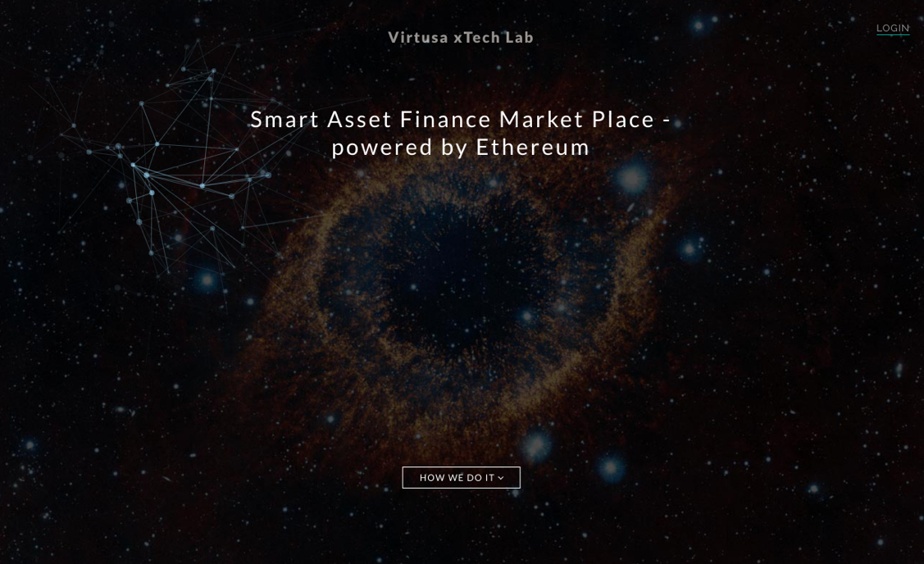

Step2:Login as a user:

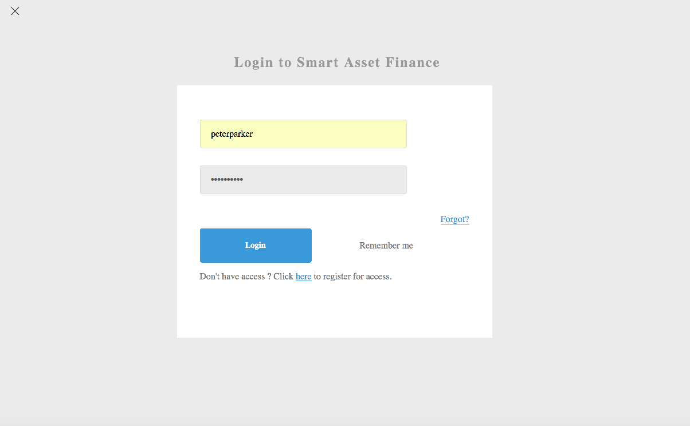

Step3: Start raise new loan by clicking Raise new loan button:

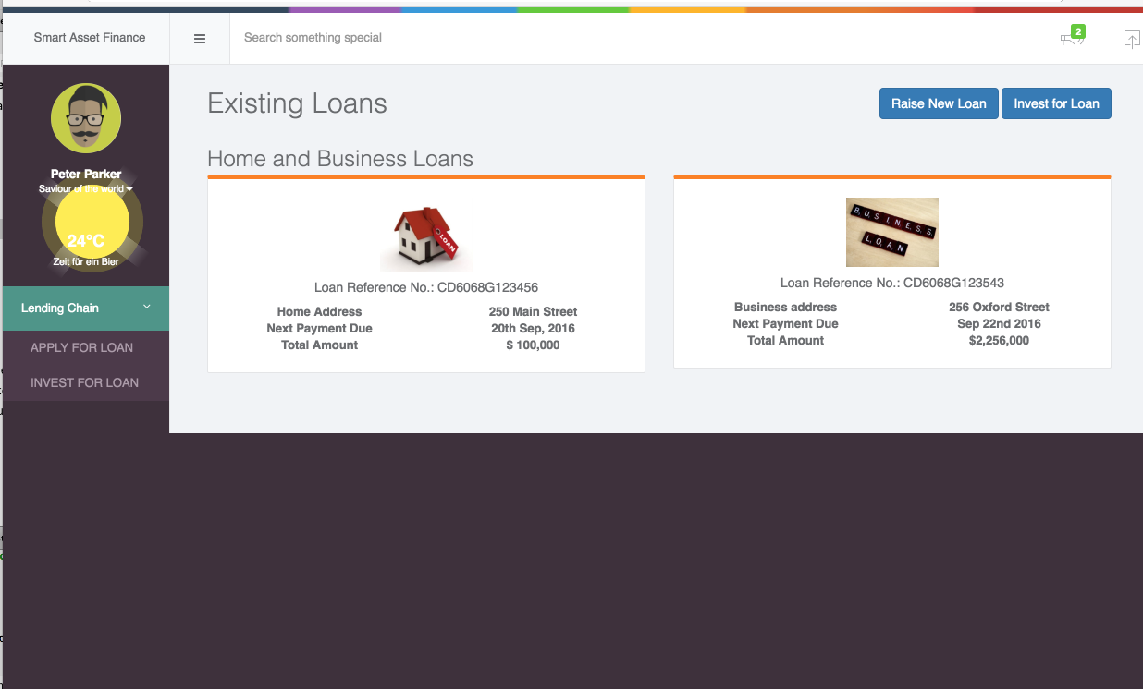

Step4:

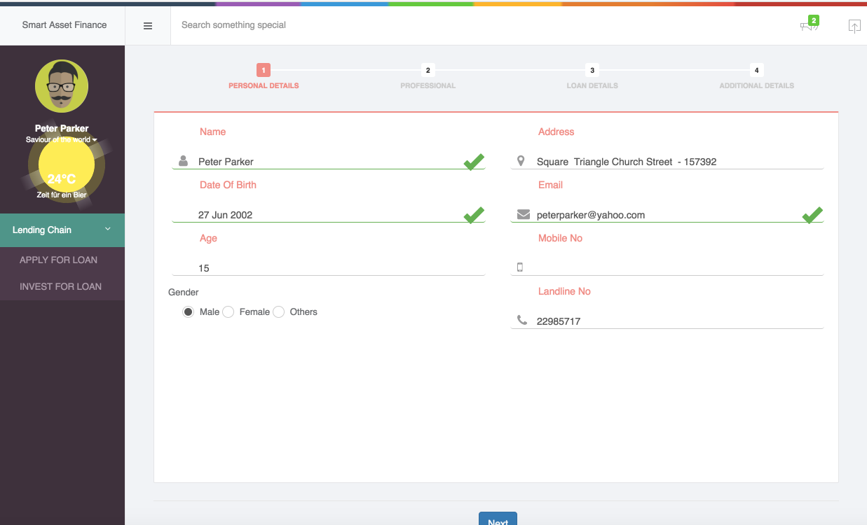

Step5:

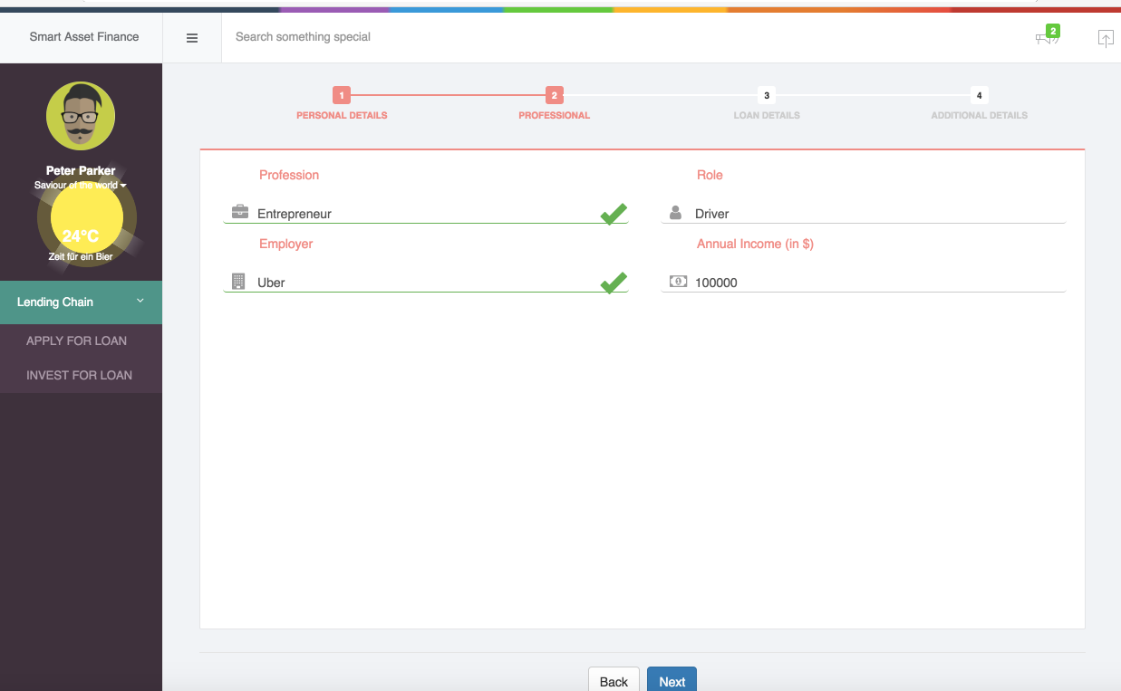

Step6: Important points to note for this screen

* Select Loan Type: Vehicle Loan
* Select Tractor make. Once Tractor make selected from drop down loan duration and loan amount field will appear
* Enter loan duration
* Select loan amount as 85%

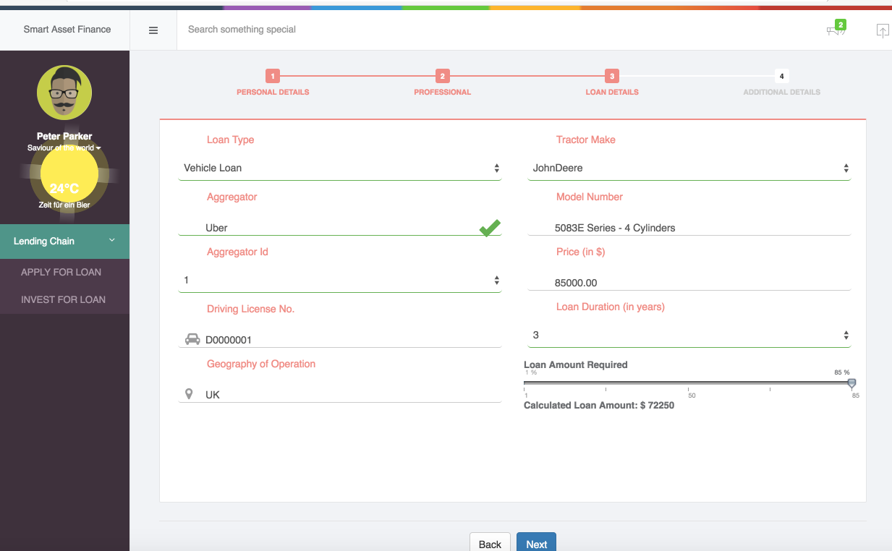

Step 7:

Enter below details to calculate loan interest. Though it is disabled now part of this deployment. Instead default loan interest shown here

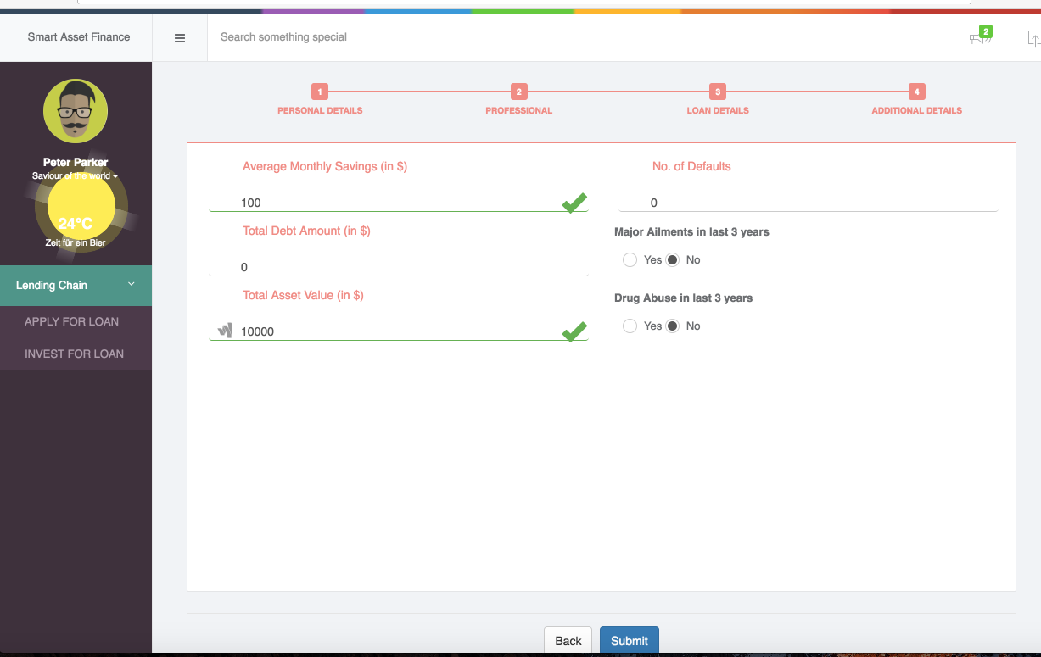

Step 8:

Click submit

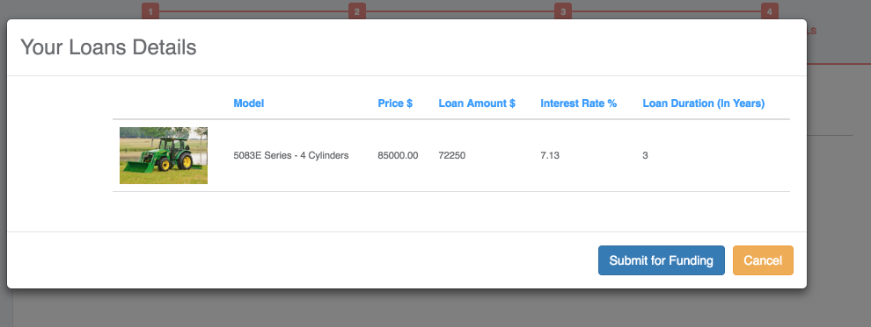

Step 9: Submit for funding

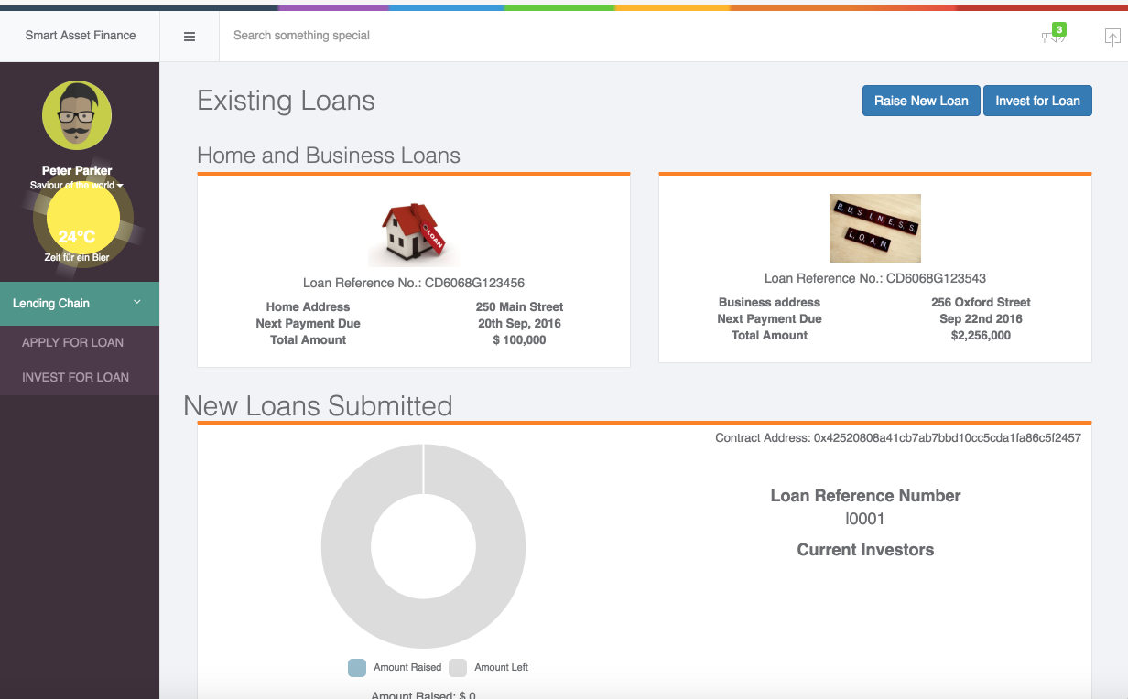

Step10: login as new user for the investment as we would not get investment option for the same user

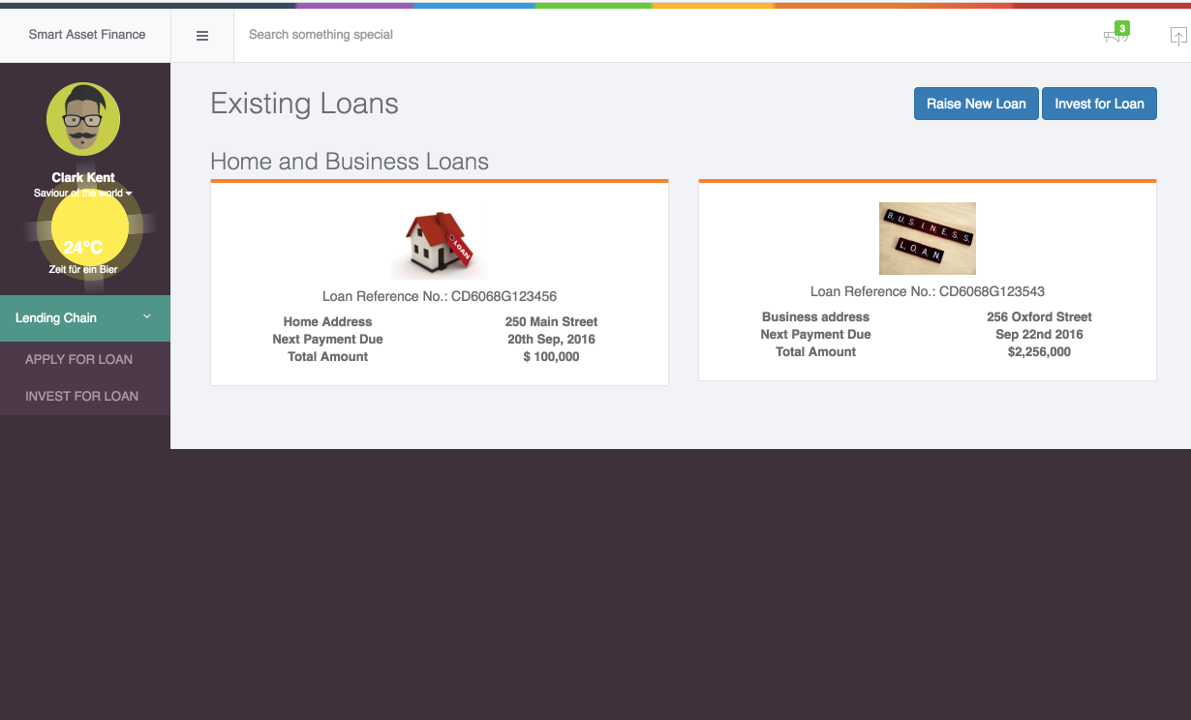

Step 11 : Go to invest for Loan click Fund loan and invest 100%. It will create an investment

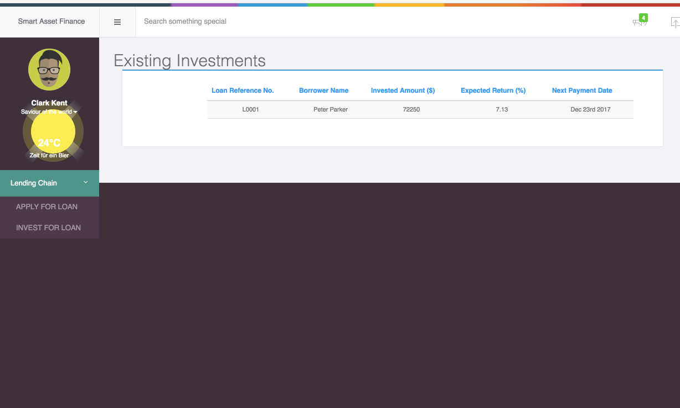

Step 12: Login as peterparker to check the loan status

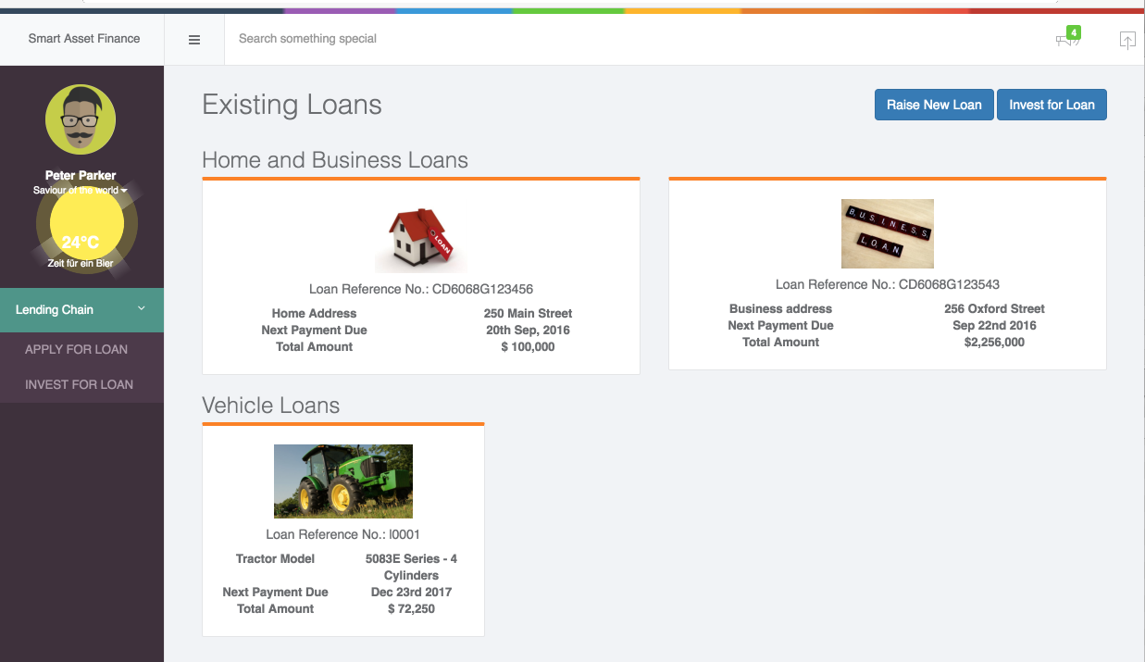

Step 13: login as banker user id is hanseldach

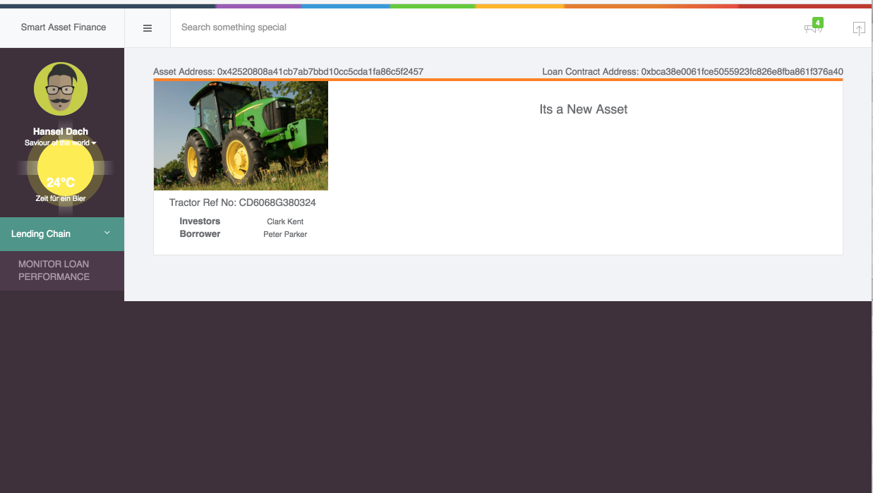

Note about asset id and loan id

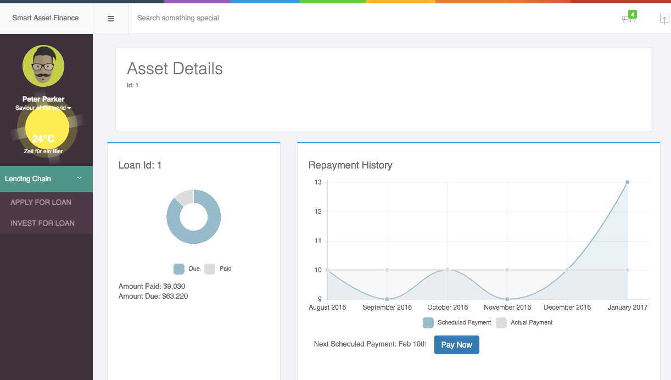

Step 14: Insert few asset and loan details through rest apis, asset details should come from tractor IOT device

Attached sample json file here.

Asset Details: http://<ip>:8080/afapi/assetfinance/setassetcondition

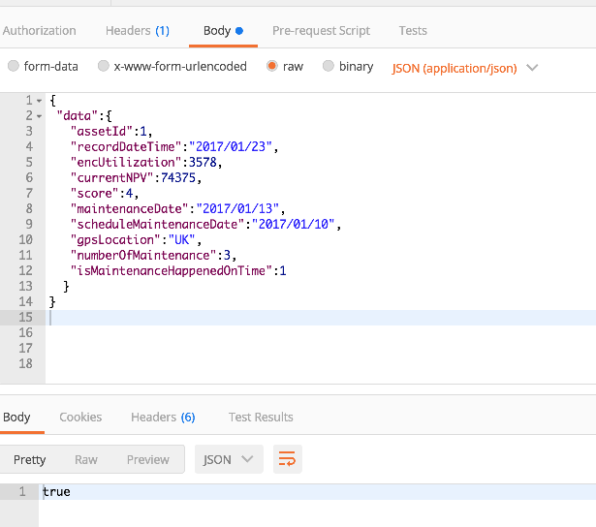

Loan Details: http://<ip>:8080/afapi/assetfinance/setloanpaymentdetails

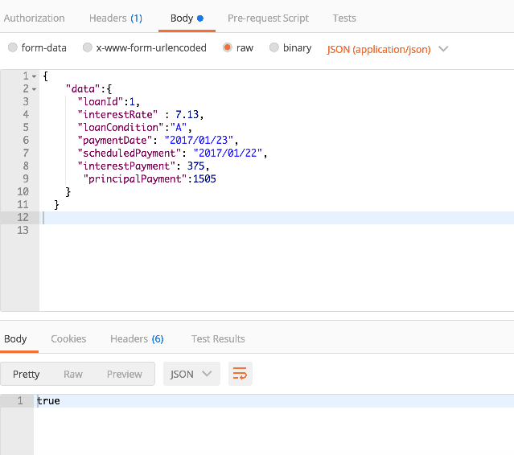

Step15: login and check the loan performance

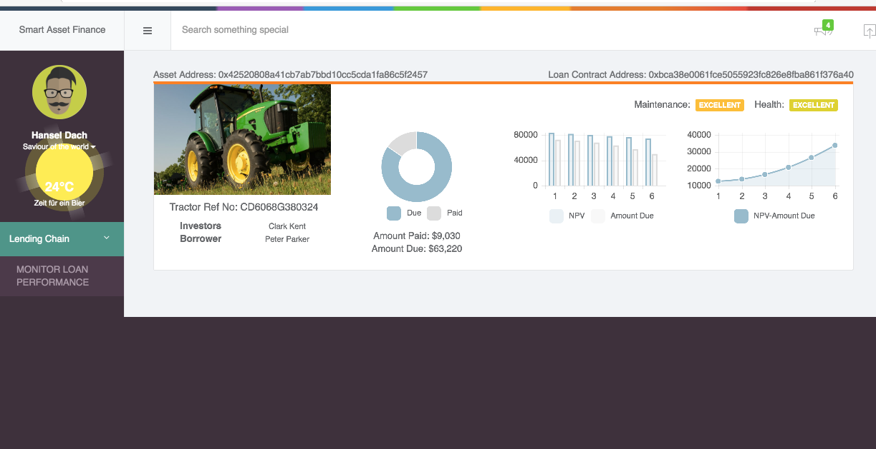

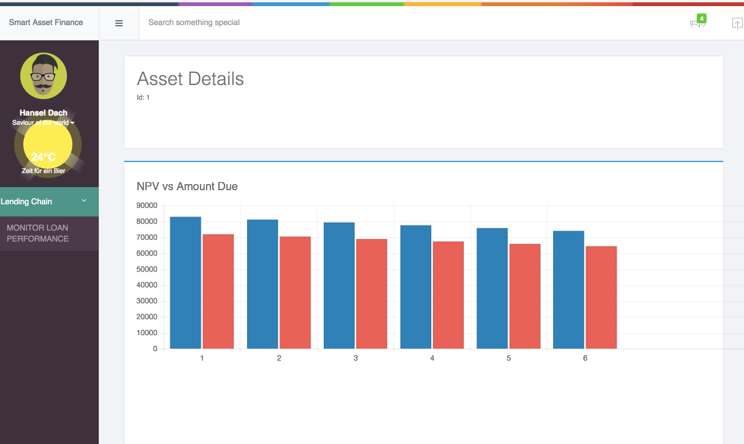

Sample IOT data set:

A. Asset Details

http://<ip>:8080/afapi/assetfinance/setassetcondition

{

"data":{

"assetId”:1,

"recordDateTime":"2016/08/25",

"encUtilization":3561,

"currentNPV":83229,

"score":4,

"maintenanceDate":"2016/08/10",

"scheduleMaintenanceDate":"2016/08/10",

"gpsLocation":"UK",

"numberOfMaintenance":1,

"isMaintenanceHappenedOnTime":1

}

}

{

"data":{

"assetId":1,

"recordDateTime":"2016/09/25",

"encUtilization":3545,

"currentNPV":81458,

"score":4,

"maintenanceDate":"2016/09/09",

"scheduleMaintenanceDate":"2016/09/10",

"gpsLocation":"UK",

"numberOfMaintenance":2,

"isMaintenanceHappenedOnTime":1

}

}

{

"data":{

"assetId":1,

"recordDateTime":"2016/10/25",

"encUtilization":3614,

"currentNPV":79688,

"score":4,

"maintenanceDate":"2016/10/10",

"scheduleMaintenanceDate":"2016/10/10",

"gpsLocation":"UK",

"numberOfMaintenance":3,

"isMaintenanceHappenedOnTime":1

}

}

{

"data":{

"assetId":1,

"recordDateTime":"2016/11/25",

"encUtilization":3570,

"currentNPV":77917,

"score":4,

"maintenanceDate":"2016/11/09",

"scheduleMaintenanceDate":"2016/11/10",

"gpsLocation":"UK",

"numberOfMaintenance":3,

"isMaintenanceHappenedOnTime":1

}

}

{

"data":{

"assetId":1,

"recordDateTime":"2016/12/26",

"encUtilization":3635,

"currentNPV":76146,

"score":4,

"maintenanceDate":"2016/12/10",

"scheduleMaintenanceDate":"2016/11/10",

"gpsLocation":"UK",

"numberOfMaintenance":3,

"isMaintenanceHappenedOnTime":1

}

}

{

"data":{

"assetId":1,

"recordDateTime":"2017/01/23",

"encUtilization":3578,

"currentNPV":74375,

"score":4,

"maintenanceDate":"2017/01/13",

"scheduleMaintenanceDate":"2017/01/10",

"gpsLocation":"UK",

"numberOfMaintenance":3,

"isMaintenanceHappenedOnTime":1

}

}

B. Loan details: http://<ip>:8080/afapi/assetfinance/setloanpaymentdetails

{

"data":{

"loanId":1,

"interestRate" : 7.13,

"loanCondition":"A",

"paymentDate": "2016/08/25",

"scheduledPayment": "2016/08/22",

"interestPayment": 420,

"principalPayment":1505

}

}

{

"data":{

"loanId":1,

"interestRate" : 7.13,

"loanCondition":"A",

"paymentDate": "2016/09/25",

"scheduledPayment": "2016/09/22",

"interestPayment": 411,

"principalPayment":1505

}

}

{

"data":{

"loanId":1,

"interestRate" : 7.13,

"loanCondition":"A",

"paymentDate": "2016/10/25",

"scheduledPayment": "2016/10/22",

"interestPayment": 402,

"principalPayment":1505

}

}

{

"data":{

"loanId":1,

"interestRate" : 7.13,

"loanCondition":"A",

"paymentDate": "2016/11/25",

"scheduledPayment": "2016/11/22",

"interestPayment": 393,

"principalPayment":1505

}

}

{

"data":{

"loanId":1,

"interestRate" : 7.13,

"loanCondition":"A",

"paymentDate": "2016/12/26",

"scheduledPayment": "2016/12/22",

"interestPayment": 384,

"principalPayment":1505

}

}

{

"data":{

"loanId":1,

"interestRate" : 7.13,

"loanCondition":"A",

"paymentDate": "2017/01/23",

"scheduledPayment": "2017/01/22",

"interestPayment": 375,

"principalPayment":1505

}

}